Below information need to be filled during the creation of test cases:

Select the Add Link from the Feature

Then choose the Work Item Type = Test Case and Linked = Tested By

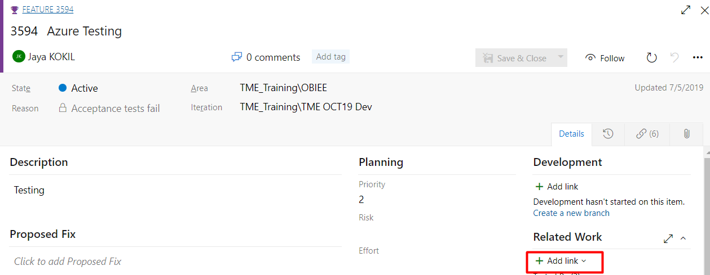

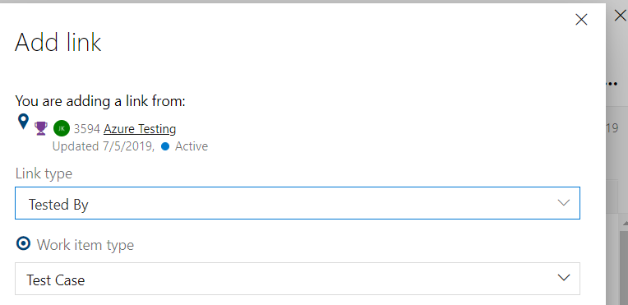

1. **Naming Convention on test case**

Use Naming Convention as follows

[Data – CHGxxxxx  - Title]

E.g Data - CHG171399 - Cluster Refresh. Check status of Siebel component.

1. **Data Execution Request**

Use following line for data execution request creation as follows:

Wait for nightly ETL or Create a Data Execution Request using this [Link](https://dev.azure.com/tsacc-msfwex01-03-TMECONNECT/TME/_workitems/create/Task?%5bITSP%20Number%5d=CHG213528&%5bArea%20Path%5d=TME\Operations\Operations%20Tester&%5bIteration%20Path%5d=TME\TME%20JUN22%20UAT0&%5bTitle%5d=Data%20Execution%20Request)

Note:

The following line can be used in TME Training:

Wait for nightly ETL or Create a Data Execution Request using this [Link](https://dev.azure.com/tsacc-msfwex01-03-TMECONNECT/TME_Training/_workitems/create/Task?%5bITSP%20Number%5d=CHG212568&%5bArea%20Path%5d=TME_Training\Operations\Operations%20Tester&%5bIteration%20Path%5d=TME_Training\TME%20JUN20%20UAT1&%5bTitle%5d=Data%20Execution%20Request)

The link should be modified to replace the CHG Number. Refer to Section

Wait for workflow RUN_AGREEMENT_BATCH in EIM_INTERFACE to complete or Create a Data Execution Request using this [Link](https://dev.azure.com/tsacc-msfwex01-03-TMECONNECT/TME/_workitems/create/Task?%5bITSP%20Number%5d=CHG229045&%5bArea%20Path%5d=TME\Operations\Operations%20Tester&%5bIteration%20Path%5d=TME\TME%20JUN22%20UAT0&%5bTitle%5d=Data%20Execution%20Request)  to execute the RUN_AGREEMENT_BATCH

CHG193858

<https://dev.azure.com/tsacc-msfwex01-03-TMECONNECT/TME/_workitems/create/Task?%5bITSP%20Number%5d=CHG193858&%5bArea%20Path%5d=TME\Operations\Operations%20Tester&%5bIteration%20Path%5d=TME\TME%20JUN21%20UAT1&%5bTitle%5d=Data%20Execution%20Request>

1. **No TS Required**

When No TS is required create a test case with Action:

“Test Case not needed as Requester knows steps to test”

1. **Test Case fields**

Assigned to: Seeburn Jagatsingh

Area Path: TME\DATA

State: Ready

Additional Information

# Links for Data execution Request

One of the concerns  we received from the markets in the post release Azure DevOps survey we did,  was related to the way they can track the progress of the “Data execution Requests”. These tasks were created independently  from a task template and without any related link to the test cases or features and for this reason markets have difficulties to know from which CR they can continue testing.

We would like to improve the way we facilitate the link in the Test Script, including the CR number in the URL itself instead of having a fixed template.

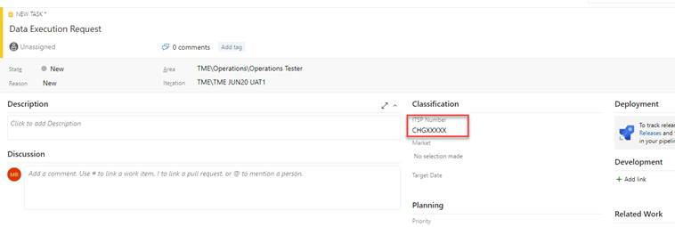

It is a very simple process that does not need a big extra effort, the unique thing you need to do is to modify CR ITSP number in the URL bellow and then include this link in the test script.

cid:image008.png@01D5A3A1.EA04E870

URL for  **TME_Training** project

[https://dev.azure.com/tsacc-msfwex01-03-TMECONNECT/TME_Training/_workitems/create/Task?%5bITSP%20Number%5d=CHGXXXXX&%5bArea%20Path%5d=TME_Training\Operations\Operations%20Tester&%5bIteration%20Path%5d=TME_Training\TME%20JUN20%20UAT1&%5bTitle%5d=Data%20Execution%20Request](https://urldefense.proofpoint.com/v2/url?u=https-3A__dev.azure.com_tsacc-2Dmsfwex01-2D03-2DTMECONNECT_TME-5FTraining_-5Fworkitems_create_Task-3F-255bITSP-2520Number-255d-3DCHGXXXXX-26-255bArea-2520Path-255d-3DTME-5FTraining-255COperations-255COperations-2520Tester-26-255bIteration-2520Path-255d-3DTME-5FTraining-255CTME-2520JUN20-2520UAT1-26-255bTitle-255d-3DData-2520Execution-2520Request&d=DwMFAw&c=eIGjsITfXP_y-DLLX0uEHXJvU8nOHrUK8IrwNKOtkVU&r=yzuLUci-A-wR2ATOaRYEbMnUId68hbaSk_EgS2gjxAU&m=tPhEZQDVVqwyoOQGlFdVi2Pr-UiNMvt_N76n9SZAYt8&s=Dur0rhxd3MLKjMsHMCFiVub8Kqou0ArmepDDevcVVh4&e=)

URL for  **TME** project

<https://dev.azure.com/tsacc-msfwex01-03-TMECONNECT/TME/_workitems/create/Task?%5bITSP%20Number%5d=CHG206426&%5bArea%20Path%5d=TME\Operations\Operations%20Tester&%5bIteration%20Path%5d=TME\TME%20JUN21%20UAT1&%5bTitle%5d=Data%20Execution%20Request>

Please, cascade down this information to your Team to include this information in the Test Cases.

Let me know if you need further details.

Many thanks for your support.

Best Regards.

Miguel Ángel.

link

Place the PR19 flat file in the IUNP folder File correctly placed

Wait for nightly ETL or Create a Data Execution Request using this [Link](https://dev.azure.com/tsacc-msfwex01-03-TMECONNECT/TME/_workitems/create/Task?%5bITSP%20Number%5d=CHG228033&%5bArea%20Path%5d=TME\Operations\Operations%20Tester&%5bIteration%20Path%5d=TME\TME%20JUN22%20UAT0&%5bTitle%5d=Data%20Execution%20Request) ETL or Data Execution completed

Check if flat file has been correctly loaded. Flat File loaded successfully

Wait of the scheduled execution of the KZ SE outbound interface or Create a Data Execution Request using this [Link](https://dev.azure.com/tsacc-msfwex01-03-TMECONNECT/TME/_workitems/create/Task?%5bITSP%20Number%5d=CHG213526&%5bArea%20Path%5d=TME\Operations\Operations%20Tester&%5bIteration%20Path%5d=TME\TME%20JUN22%20UAT0&%5bTitle%5d=Data%20Execution%20Request) to execute the KZ SE outbound interface

|  |  |
| --- | --- |
| Login on sales application as CSTADMKZ Go to the Service Request  Verify or create test data as per market business rule for the SE KZ outbound interface | Test data available for SE Interface |
| Wait of the scheduled execution of the KZ SE outbound interface or Create a Data Execution Request using this [Link](https://dev.azure.com/tsacc-msfwex01-03-TMECONNECT/TME/_workitems/create/Task?%5bITSP%20Number%5d=CHG213526&%5bArea%20Path%5d=TME\Operations\Operations%20Tester&%5bIteration%20Path%5d=TME\TME%20JUN22%20UAT0&%5bTitle%5d=Data%20Execution%20Request) to execute the KZ SE outbound interface | Workflow executed successfully |
| Check if SE outbound file has been generated in the market OUNP folder | KZ SE outbound file has been generated in the market OUNP folder |
|  |  |
|  |  |
|  |  |
|  |  |